PROJECT

READING THE VALUES OF TEMPRATURE AND HUMIDITY USING DHT11 SENSOR ON ARDUINO.

In this project we have used a DHT11 sensor with Arduino Uno board. This sensor can read the values of temperature and humidity for 0-50 degree Celsius and 20-95% of humidity. It is very simple to connect as it has only three pins namely GND, Vcc and Data pin.

The printing of data from DHT11 sensor was done on 16x2 LCD display which was compatible with Arduino

Circuit and Working

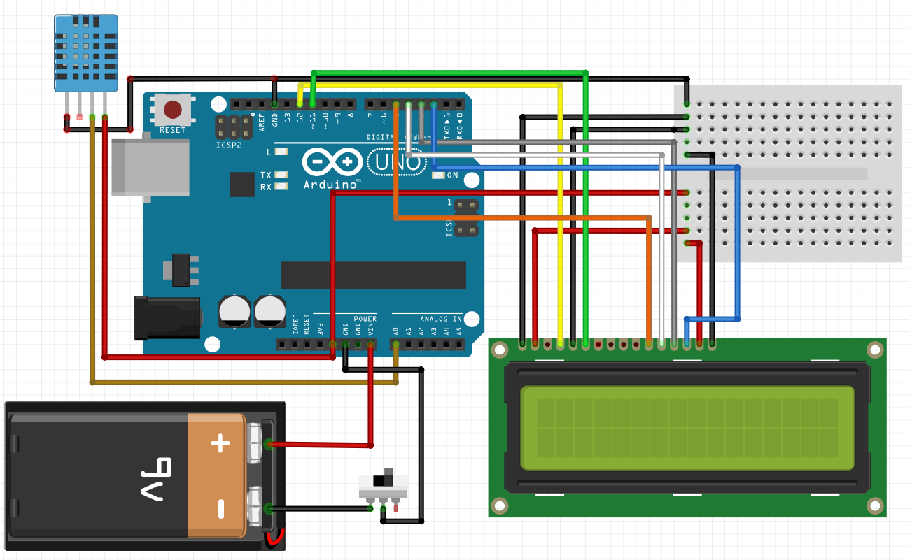

PIN CONNECTIONS

For LCD, from left to right pins are defined as VSS, VDD, VO, RS, RW, E, DO, D1, D2, D3, D4, D5, D6, D7, Anode for backlight and (K)Cathode for backlight.

For DHT11 sensor left to right GND, Data and Vcc.

VSS, RW and K were connected to ground in LCD and RS, E, D4, D5, D6, D7 were used to transfer of data to print on LCD. Rest of the pins of LCD were remain unused,however some LCD requires contrast for which VO can be connected to ground through 5K ohm resistor.

WORKING

Whenever some data is sensed by DHT11 sensor it is received by Arduino and sent to LCD where LCD displays the live data of sensor. The delay time can be changed in the code to make LCD refresh faster and it may display the data more accurately .

CODE

#include<LiquidCrystal.h>

#include"dht.h"

intdhtPin=A0;

dhtDHT;

LiquidCrystallcd(12,11,5,4,3,2);

voidsetup(){

Serial.begin(9600);

lcd.begin(16,2);

Serial.println("DHT11 Humidity & temperature Sensor\n\n");

}

voidloop(){

DHT.read11(dhtPin);

Serial.print("Current humidity = ");

Serial.print(DHT.humidity);

Serial.print("% ");

Serial.print("temperature = ");

Serial.print(DHT.temperature);

Serial.println("C ");

lcd.setCursor(0,0);

lcd.print("Humidity ");

lcd.print(DHT.humidity);

lcd.print(" %");

lcd.setCursor(0,1);

lcd.print("Temp ");

lcd.print(DHT.temperature);

lcd.print(" C");

delay(500);

}

